ASSIGNMENT 6

AIM:

To design 8-Bit Adder, 8-Bit Register and 16-Bit Counter.

CIRCUIT:
1. 8-Bit Adder has been constructed as follows -
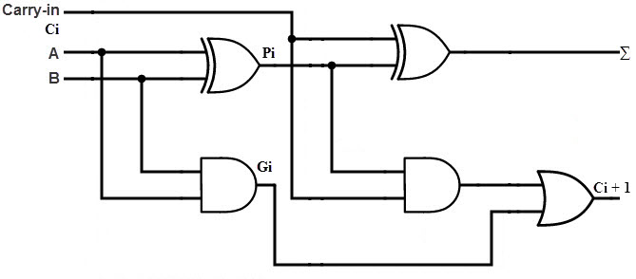
1-Bit Adder

8 of these bit adders are joined together to form the 8-bit adder.

2. 8-Bit Register has been constructed by first constructing as follows -
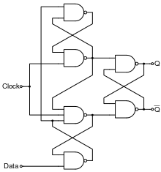

8 of these registers are joined together to form an 8-bit register as follows
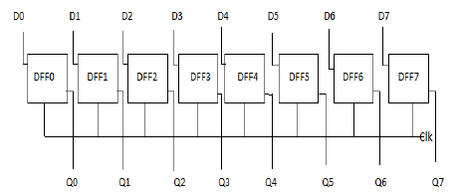

3. 16-Bit Binary Ripple Counter using 16 D-Flip Flops
A single D-Flip Flop with CLEAR and PRESET pins is built as such -

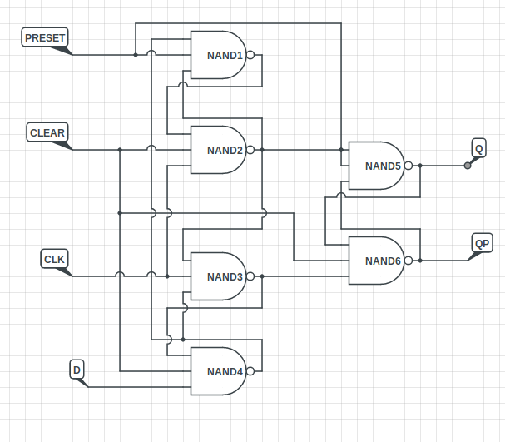

16 of these D-Flip Flops are attached in the following manner
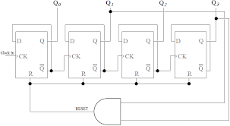

OBSERVATIONS:
1. The adder worked correctly for 0110011 + 11001100 = 00110100, Cout=1
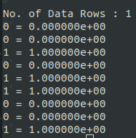

2. It can be seen that the register is storing the given data – (0 to 1 for D0 and 1 to 0 for D1)
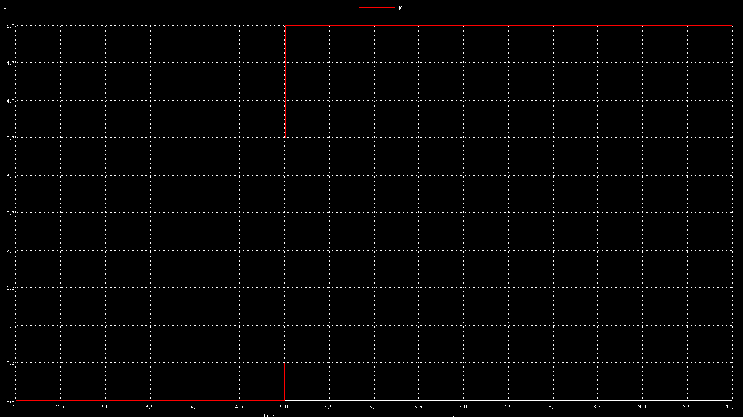
D0

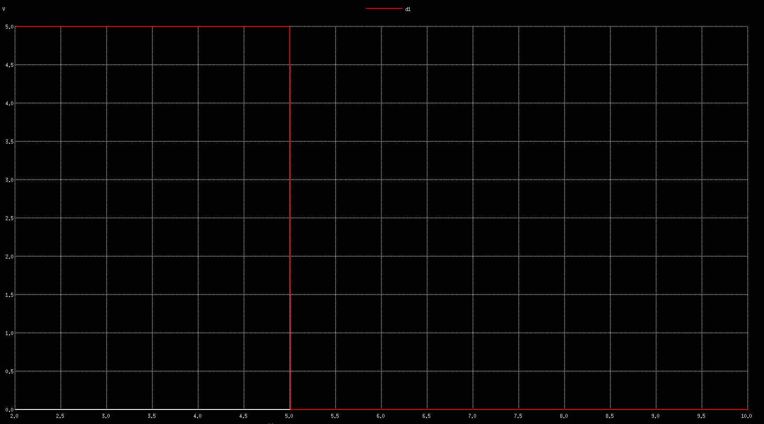
D1

CONCLUSION:
The circuits work as expected except for propagation delays.

